

**WAREHOUSE MANAGEMENT APPLICATION**

**LOW LEVEL DESIGN**

**Overview of Warehouse Management Application:**

Warehouses sit at the centre of manufacturing and supply chain operations because they hold all the material used or produced in those processes, from raw materials to finished goods.

The purpose of a WMS is to ensure that goods and materials move through warehouses in the most efficient and cost-effective way. A WMS handles many functions that enable these movements, including inventory tracking, picking and supplying.

**Procedure Flow:**

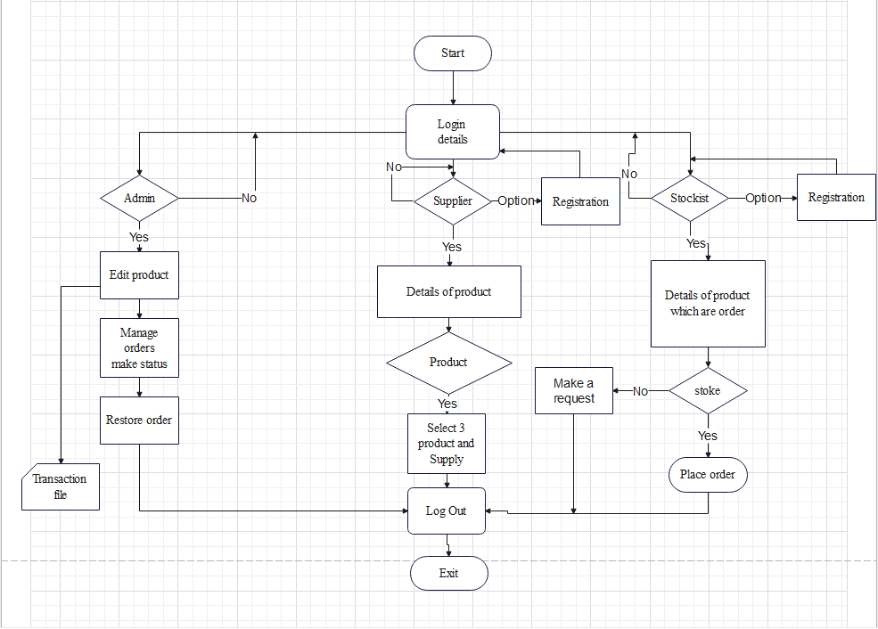

* **Login Details:**

The username and password are provided to the registered user to access the portal.

The admin can login directly.

* **Supplier Registration:**

If the supplier is new, then supplier must register himself with new supplier ID and password.

* **Stockist Registration:**

If the stockist is new, he should register himself with new stockist ID and password.

* **Edit Product:**

The admin can edit the product details like the product ID, product name and stock availability.

* **Manage Order Status:**

The admin can manage the order status by a status indicator called ROL (Re-Order Level) which is present in the product file.

* **Restore Order:**

When the ROL is less than the set value then the admin restores the stock level.

* **Transaction File:**

Report would be generated for ordered product details, stockist Id, Product Id and quantity.

* **Product Details:**

This file contains all the details regarding the product like the product name, product ID and details.

* **Select 3 product to supply:**

The supplier selects the three products that he can supply selected from the product file.

* **Make request:**

A request is made to order the product.

* **Place order:**

The order is placed and then delivered which is also tracked.